Tutorial 1
SPEEDOMETER
- You need to have a plane for the ground and a cube for the car, go to the hierarchy, 3D objects and add a cube, rename it to the car and add a plane rename it to the ground
- Because we are going to drive this car with the Physics system by moving rigidbody around that’s because we want the car to accelerate and decelerate, so You need to add a rigidbody to the cube, so click one the car(cube) in the hierarchy, then on inspector, add component, add a Rigidbody to it
- As you can see on the hierarchy we have a main camera and that’s is the camera that we are going to make it to follow the car so you need to put it in the good position behind the car, click one the main camera in hierarchy and press W on your keyboard and change the position of you camera and after you put it in the right position drag the main camera in the hierarchy and add it car so it follows the car.
- Now it’s time for programming, click on the car in the hierarchy and go the inspector and add a script call it PlayerController.

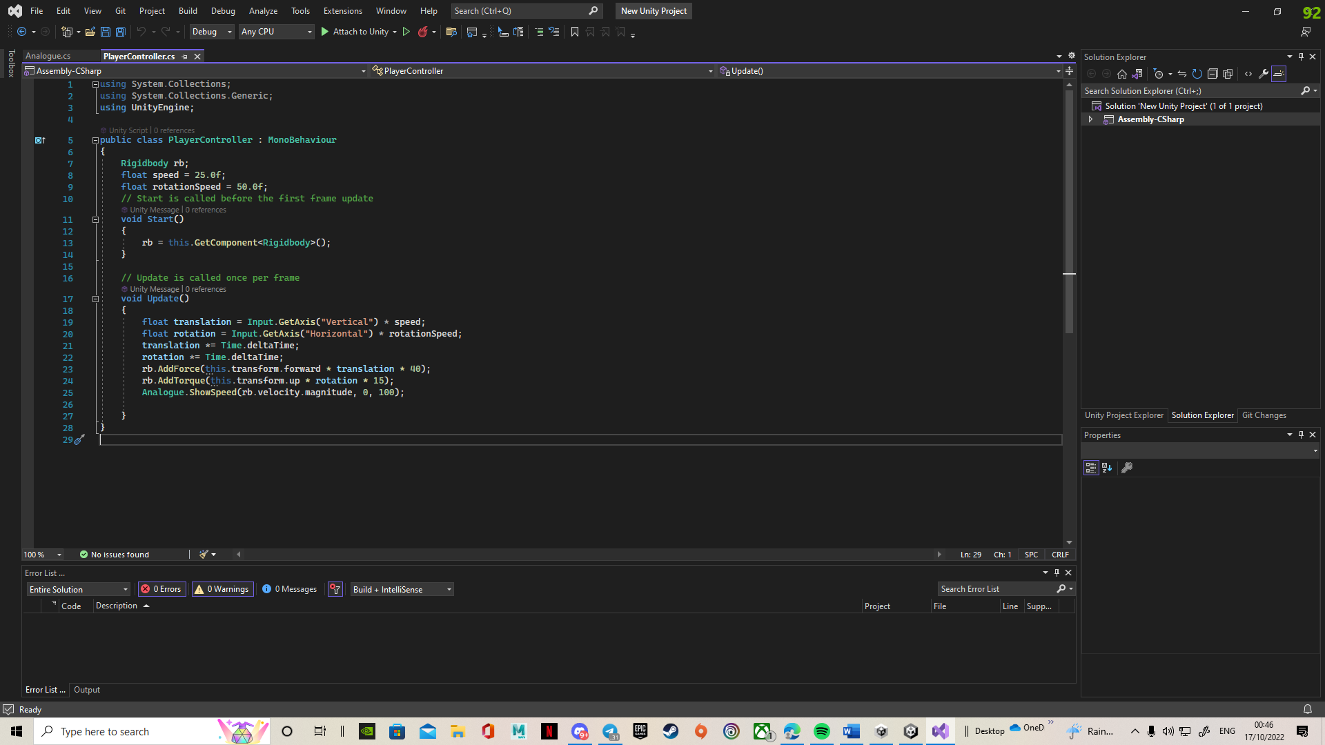
- We have a variable at the top, we called it rb to grab hold out rigidbody
- Then we have added the speed value and rotational speed value that’s because car can go straight line, or it can also turn on the spot
- In the update function, you can see we are using vertical and horizontal axis too get the translation and rotation. So, we are using up and down arrow keys or W or S for moving forward and back and using left and right arrow keys or A or D for rotation
- Then we need to multiply our translation and rotation to time.deltatime and that is because if you run this project on the slow pc or a decent pc, you can drive the car with same speed, it’s not going to change.
- We need to move the rigidbody by adding the force to it and it need to be for the forward direction, and we are going to multiply it to translation and multiply it again to 40(this is up to you if the cube is moving with this number its fine if not you need to play with it to find the number.
- For the rotation we need to ad torque and in this case the torque is going to rotate the object around its up vector and multiply it to rotation and 15
- About the last line forget it, we will come back to it
- Save the script (ctrl + s) then go to unity on the rigidbody section you need to find the constraints and in the freeze rotation you need to click on x and z so it will only rotate around the y.
- Now if you start to play your scene you can understand if your car is moving or not and that because of the colour the terrain and the cube
- On you project
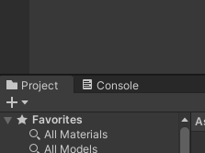
You need to add a material so you need to right click on the assets and in the create button add a material, when you added the material click on it and on the top right you can change the colour so find the colour that you like and drag the material and add it to the car and to the same thing for the ground but with the different colour.
- Now go to the hierarchy, right click on it, 3D objects and add a cube, when you add the cube click on it and go to the inspector, you can see the scale make it big like a building and put at the end of your terrain by using W key and changing the positions so you can see your car is moving.
- It’s time for adding our speedometer, at the first you need to add the canvas, so right click on the hierarchy go to UI section add a panel.
- When you added the panel, you can see you have canvas as well, now you need to change your panel size so put your unity to 2d
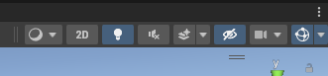
and click on the panel, make it smaller and put it at the bottom left (it’s the place that speedometer will shows)
- next you need to have a speedometer and an arrow image; you can download it from internet and drag it into your project
- When you add images into your project, click on the panel and on the inspector/image script, you can see a section called source image, that is the place to add your speedometer, but before everything you need to click on the speedometer and in the inspector you can see a texture type so change that to Sprite (2D and UI ) do the same thing for the arrow image as well; now it’s time to drag the speedometer image and drop it into the source image of the panel
- Now you can see the speedometer on your screen, but it’s hard to see it, click on the colour section of the panel, now we have 4 different section A, B, G and R you need to change the A section so bring it to 255
- It’s time for our needle so right clicks on the panel, UI, add an image and drag the arrow image to the source image (if it didn’t show up in the middle of the speedometer, bring it) play with it in the scene section to find the best scale for yourself.
- Next you need to register the angle that it is on when it is on the minimum speed and the maximum speed because we are changing the values between these two angles. So, on the inspector you can see the angle in the Z in the Rotation section, write the number down so you can remember it and rotate the arrow to the maximum speed and write that number down as well.
- It’s time to programming now, add a script to needle and named Analogue1
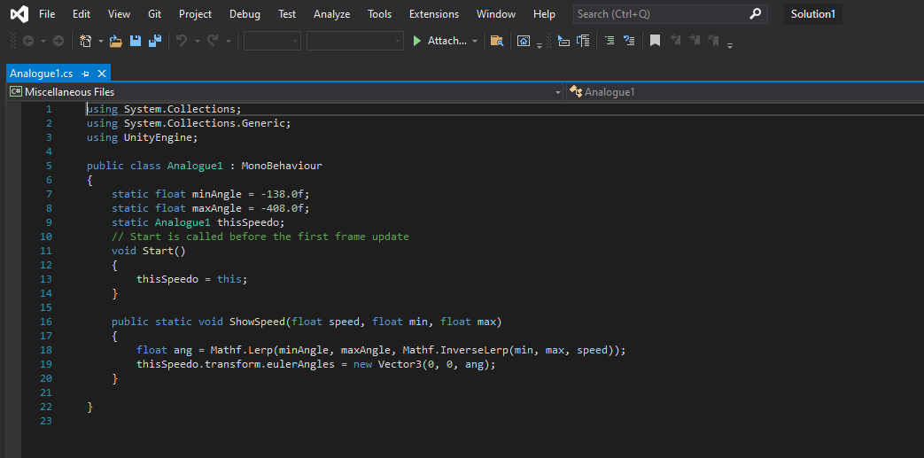
You need to add values at the top and we need to have it on static so we can use it on different scripts on these values you need to add your minimum and maximum angles.
We are going to create an instance of this actual speedo so we can access it from our static function.
In line 16 we have speed that come from velocity, and we give the function a minimum and maximum speed that our car can achieve.
Iline 18 will give us an angle value which is going to be between your min and max angle number and then we used the ang that we got in line 18 in line 19 and line 19 make the needle rotation.

- Now your speedometer is ready, have fun

